Hospital Database Management System

Introduction:
This project is mainly revolving around Hospital Databases. As proposed earlier, I chose this topic as it would be easier for me to understand how the entities in the hospital databases work. The minimal goals of the project was to build the database and have the database running while the optimistic/pessimistic goals of the project were to build Pharmacy Management, InsuranceClaims, and Patient Feedback Survey.

Exploring:
Before this project/lectures, I had little knowledge on SQL and Databases, as much as writing SQL Queries and understanding them. My initial idea for the project itself was this Hospital Database Management System and I did refer to other resources on the web and github forums. However, I still decided to go with the Hospital Database Management Systems.

Building:
So, all my data for this database is AI-generated and did not use any other tools. Basically, they are kind of hand written.

Discovering:
Before this lecture, I was not that familiar with implicit/explicit joins, normalization concepts and data modelling in general. But after the lectures, especially while doing the assignments everything strated to make sense. While there is one more goal pending from the project which was to build a Patient Feedback survey, however due to time constraint I am not able to do that for the moment.
Challenges:
While creating the table Appointment, I initially thought it would be better to have the patient’s and doctor’s names as unique values but that would not be possible because two patient’s or doctor’s may have same name and the name can change in future. So, I just went with patientId and doctorId to ensure uniqueness between the rows.

Topics from Lectures:
- Normalization:

1NF:
- Since the entries or values in the database, does not depend on row ordering it satisfies First Normalization form
- Each entries or values in the database has a primary key.
2NF:
- All the attributes in the entries are dependant only on the primary key only.

3NF:
- The entries in the database do not have any transitive dependencies.

- DDL
Implicit and explicit joins which are crucial in joining two or more tables together, I became familiar with that after the lectures.
- Advanced SQL Features
Views:
Before the lecture, I was unsure about views. Here are some views that I have incorporated in my database:
CREATE VIEW PatientDoctorInfo AS
SELECT p.firstName AS PatientName, d.firstName AS DoctorName, d.specialty
FROM Patient p
JOIN Doctor d ON p.patientId = d.assignedPatient;
This view helps us to view the information about the patients alloted to a doctor and vice versa.

CREATE VIEW NursePatientView AS
SELECT
Nurse.nurseId AS NurseID,
Nurse.firstName AS NurseFirstName,
Nurse.lastName AS NurseLastName,
Nurse.specialty AS NurseSpecialty,
Nurse.reportingDoctor AS ReportingDoctor,
Patient.patientId AS PatientID,
Patient.firstName AS PatientFirstName,
Patient.lastName AS PatientLastName,
Patient.mailAddress AS PatientMailAddress,
Patient.admissionDate AS PatientAdmissionDate
FROM
Nurse
LEFT JOIN
Patient
ON
Nurse.assignedPatient = Patient.patientId;

This view helps us to view the information of patients assigned to specific nurses.

- Relational Model/ Data Modelling:
Before the lecture, I was not aware of cardinalities in DBMS nor the entities or the relationships involved. Here, let’s take a look at the ER diagram of this database:
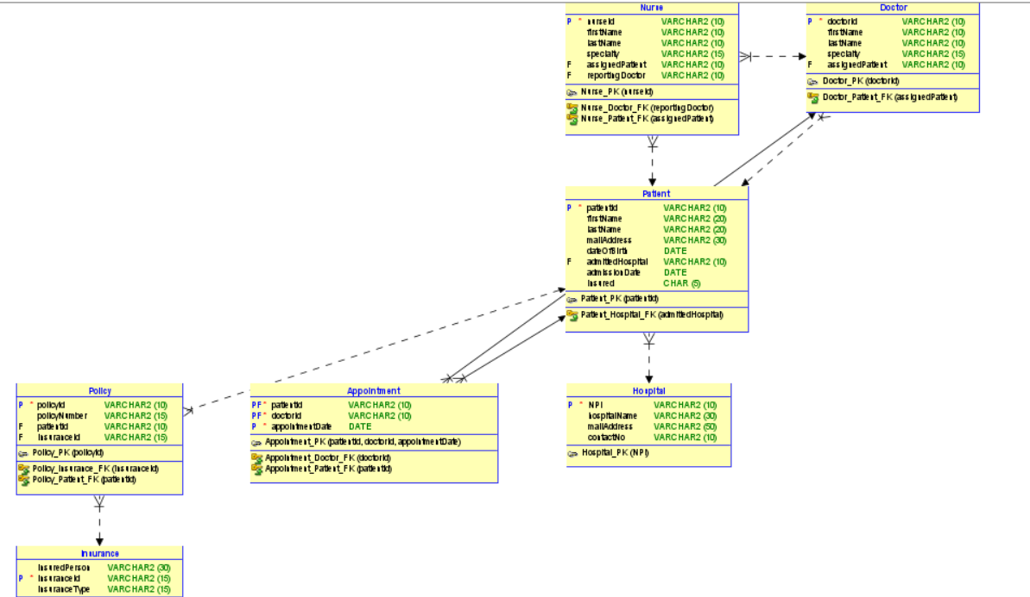

Doctor to Patient (One to Many):
A doctor can have many patients and although it is possible for a patient to have many doctors, in this database design however that is not the case.

Nurse to Doctor (Many to One):
In this relational model, many nurses can report to a single doctor.

Nurse to Patient (One to Many):
Many patients can be under a single nurse’s care. So, the cardinality between the nurse and the patient is one to many.
Hospital to Patient: ( One to Many)
A hospital can have many patients. However, it is possible for a patient to get admitted in a single hospital at a time.

Pharmacy Management Relational Diagram:
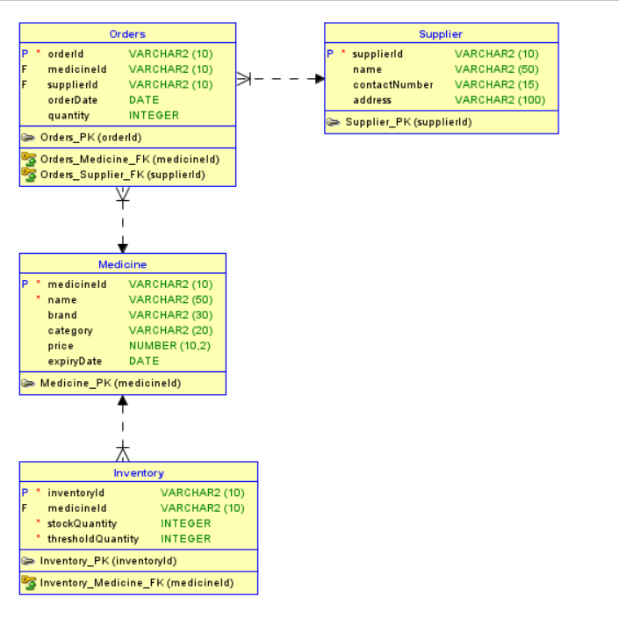

Orders to Supplier (Many to one): A supplier can have many orders
Orders to Medicine(Many to one): Medicine can have many orders
Inventory to Medicine (Many to One): Inventory can have many stocks of medicine

InsuranceClaim Relational Diagram:
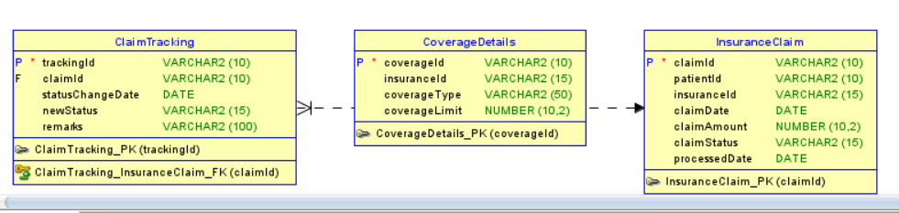
ClaimTracking to CoverageDetails (Many to One): A single coverage plan can have multiple claims.
CoverageDetails to InsuranceClaim (one to One): CoverageDetails to InsuranceClaim is one to one because the claim can be either approved or rejected in this case.

- Database design:
Before this project, I had no experience in designing databases. However, this project made me expand my idea of databases and made me design this database.

